Runoff in a Bottle – An Inquiry
Leave Your Leaves Curriculum, 9-12: Lesson 3 plan and activities

NC Essential Standards:

- Bio.2.2.1 Infer how human activities (including population growth, pollution, global warming, burning of fossil fuels, habitat destruction and introduction of nonnative species) may impact the environment.
- EEn.2.1.3 Explain how natural actions such as weathering, erosion (wind, water and gravity), and soil formation affect Earth’s surface.
- EEn.2.2.1 Explain the consequences of human activities on the lithosphere (such as mining, deforestation, agriculture, overgrazing, urbanization, and land use) past and present.

Objectives:

- Examine the effects of various surfaces on runoff, erosion, and silt
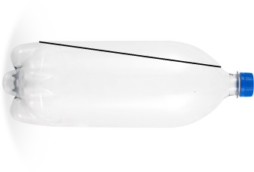

- Use the basic principles of experimental design and analysis

Required materials (for a class of 28 students working in lab groups of 4):

- Empty 2-liter bottles, cut as seen to the right (3 per lab group – 21 total)
- Empty 1-liter bottles, cut as seen to the right (3 per lab group – 21 total))
- String for hanging 1-liter bottles
- Soil (something that can be compacted, like clay)
- Leaf litter
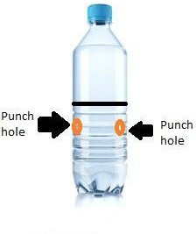

- Cement (or something solid to fill the bottle with an impervious surface)
- 100-mL graduated cylinder (7 total) Vocabulary: runoff, erosion, impervious, pervious, silt Helpful Teacher Websites:
This video would be helpful for the educator to get an idea of how to set up the bottles (not t https://www.youtube.com/watch?v=im4HVXMGI68
o be shown to students).
Runoff in a Bottle
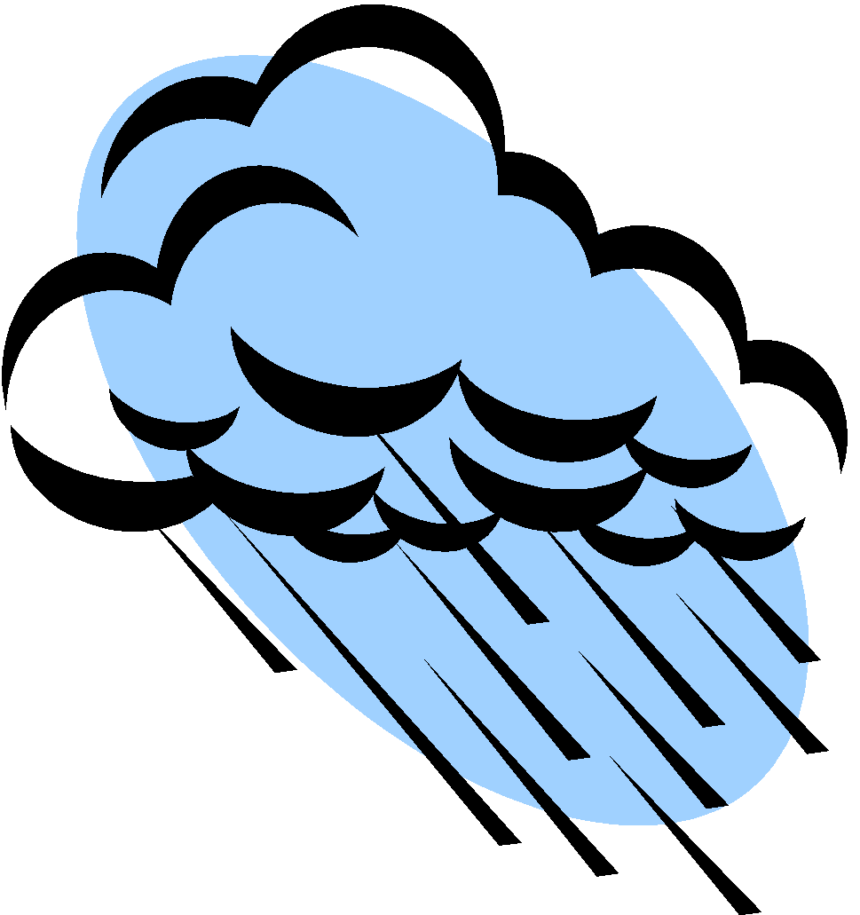

Lesson 3 Student Worksheet

Pre-lab Questions:

- What is the difference between impervious and pervious surfaces?

- Describe how runoff, erosion, and silt related and the effect that they have on the environment.

Purpose: To investigate runoff and erosion in three different soil systems: cement, compacted soil with nothing else on top, and soil with leaf litter on top

Materials available:

3 modified 2-liter bottles (1 containing cement) 3 modified 1-liter bottles
soil
leaf litter water
- mL graduated cylinder

Hypothesis: Consider the pre-lab questions, choose a variable you want to explore, and write a hypothesis about the three different soil systems.

Our independent variable is and our dependent variable is .
Procedure: Write a detailed procedure for your experiment. Consult with your teacher to get approval before conducting your experiment.

Results: Create a data table for your results. Be sure to include all of the parts of a good data table.

Analysis:

  - What conclusions can you draw from your results? Support your answer with data.

  - What changes might these data lead you to recommend to leaders in your community? Why?

  - Describe one way you might modify your experiment in the future in order to improve the validity of your data.

